**Create Folder using Command prompt**

This document is created for the purpose of **“create zap folder using cmd through”.**

**Step 1:** Double click on **“Create folder using command prompt. Zappy”**

**Step 2: Run Zappy Task** Window will pop up, click on **OK**.

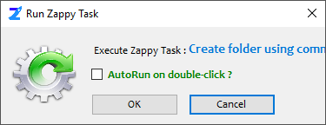

**Step 3**: Select location where you want to create Z**ap** folder.

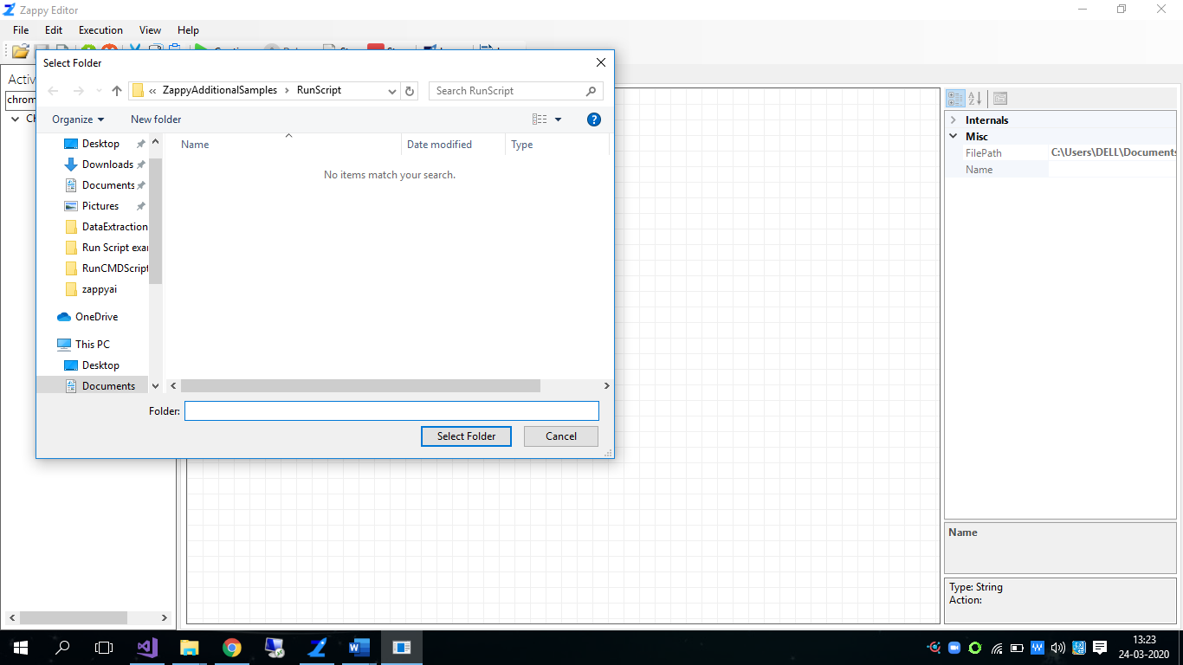

**Output:** Zap folder is created in selected Location.

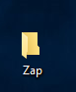

**How To Modify:**

We can modify this automation in task editor.

Open this Automation by clicking on Open  button.

We have to only change the **Zap** name and **enter any name as you like**.

